Kravitz employees App
Final Project Definition

By:
Idan Lazar
Yonatan Ben-avraham
Ronel Shem-tov
Ori Litman
Yuval David

Supervisor:
Eliav Menachi

Git:
https://github.com/yonbav/FinalProject

Table of Contents
1. Project description 2
2. Related Work 2
3. Functional Description / Requirements 2
4. Architecture 3
4.1. Each Module description 3
5. Work plan 3
6. Client side 3
6.1. Usage Illustration 3
6.2. Mockup 3
7. Server Side 3
7.1. API 4

Project description

The project will provide a solution for any company management a way to inform its employees of administrative details, professional information and special events in a secure and efficient way.

The product will provide:

A management interface where they can enter the relevant updates, their distribution method (push / upload content) and the relevant target user group.

An Android application for company employees that updates them in a simple and convenient user interface with the required updates.

The product infrastructure will be able to serve any type of company and the adjustments that can be made according to the company (look and feel), the working method with its employees and the information required to be transferred between management and employees.

The first company that will implement the solution will be - Kravitz, a leading company in Israel, supplies and distributes stationery, office equipment and furniture, peripheral equipment, electronics, art products and gifts.
The company operates a retail chain of 75 stores which is spread throughout the country and faces a challenge of multiple employees and high turnover

The company has two types of stores:
1. Versatile store for the entire population (Kravitz).
2 Custom store for students (Academon).

Related Work
Today, there are products in the market that enable the ability to update and perform various actions between employee and management in large and small organizations, for example:
- Depoint
- connecteam

These types of products allow for a wide scope of operations, and thus the costs of fundraising for the organization and implementation are expensive.

The purpose of our product is to enable the basic capabilities required to update the employee at low cost and in minimal integration in the organization.

The technologies we use enable us to develop a flexible and efficient product
- Client Side - React -Cross-platform language – will enable us to implement the UI for the client to IOS, Android and web in simple method
- Server Side - Node.js - Allows asynchronous requests to the database

Functional Description / Requirements

The management interface enables the following functionality:
- managing documents of various kinds - daily update, professional training Ext. the admin should have the ability to do following actions on the documents
  - Upload, update, delete
- Create an update by writing free text by the administrator to update the employees.
- Create a link to the document \ external page.
- For each type of content, the admin will specified:
  - Security settings: the relevant user type that can access the information will be defined.
  - path- where the data need to be shown in the client app.
- The management interface can work in parallel from 2 workstations (or more)
- Managing users table for authentication and authorization.

The user interface will allow the following capabilities
- Access from an android application with email and password authentication.
- Ability to read all the content described in the administrative section from a convenient interface built hierarchically.
- Display only relevant information according to the security settings on the relevant content.
- Search capability.
- PUSH NOT

Security requirements:
- Identification with an internal user table that will be managed by the management interface.
- Employee classification according to the following categories:
  - Seller at store from type A (Kravitz)
  - Seller at store from type B (Academon)
  - Manager at store from type A.
  - Manager at store from type B.
  - Admin.
- When user accessing information (of any kind) from the client the system willst block the ability to take screenshots of the software - not a mandatory requirement

Architecture

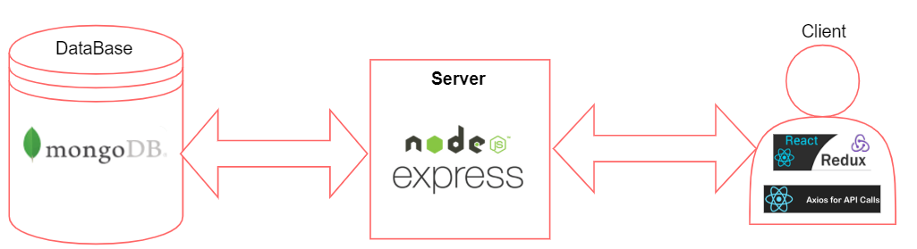

React

Advantages:
- Writing once deploy everywhere: As one of the requirements of the project is to create an Android application as well as web application for Kravitz managers. React Native along with React JS will allow us to write the whole client side with the same technology. Will also be able to create an IOS application with minimum effort.
- Big community for support: React has a very big community. That will make it a lot easier to learn, will have a wide community to consult with online in case of an issue we can't resolve.
- Big company that is responsible for the framework: React is maintained and developed by Facebook. That means it is highly reliable and secure.

Disadvantages:
- Not fully computable: Writing native code will always allow us to have a better control on our Android or IOS Application. According to current specification none of the features are complex enough to prevent us from using react native.

Redux + Oxios

Advantages:
- Allows us to easily manage our state in the react app: Using redux will allow us to manage easily a single state for our application. The biggest advantage will be code that is more organized and easier to understand. Beside that in organized code it will be easier to add new features and the project could scale without turning into a mess.
- Oxios will make for us all the JQuery request to the server: Will save us to implement it ourselves and will keep the requests to our server well organized.

Disadvantages:
- Will force us to do things the "Redux way".

NodeJS

Advantages:
- Asynchronous request to the database: One of the most known problems in large scale websites is the C10K problem, which describes how a website should optimizing network sockets to handle a large number of clients at the same time. One good advantage that node has to help solving that problem is to create asynchronous calls to the database which very often is the bottle neck.
- Open source that has a big community: NodeJS has a very big community, that will make it a lot easier to learn, will have a wide community to consult with online in case of an issue we can't resolve. If will have a feature that we need for our app we can create a fork and develop that feature.
- Writing server side in JavaScript: NodeJS is written in java script which is the same language that we write our client side with. That will allow our developers to know only one language in order to write the server and the client.

Disadvantages:
- Lack of support of operation system multithreading: Java script won't do well if will need to do complex calculations in the server that requires all the server's resources. (For example, training a learning algorithm)

ExpressJS

Advantages:
- Offers a simple way to get a server up and running and promotes code reuse: Using ExpressJS will allow us to deploy our server easily and faster.
- Open source that has a big community: ExpressJS has a very big community, that will make it a lot easier to learn, will have a wide community to consult with online in case of an issue we can't resolve. If will have a feature that we need for our app we can create a fork and develop that feature.

Disadvantages:
- There is a lot of manual tedious tasks involved in Express: will have to put some effort to learn how to use Express. It will probably be time consuming at the beginning, but after that it will be easier to deploy the server.

MongoDB

Advantages:
- Save the models as Json, which means there is no need for mapping the application objects: Using MongoDB will allow us to save our data as Json. That will save us the conversion from table like rows to json and from Json to table like rows. That way we can easily convert json in our server without mapping the objects in the application.
- Very big community and a very comprehensive tutorials: There is an official website with very good documentations. That will make it easier to learn. Beside that there is a big community to consult with online when you encounter difficulties.
- Very easy to scale: MongoDB can save and manage huge amount of data, I incase our application will grow and have a lot of users
- There is no VM needed in order to run it. Can be run as windows service as well.

Disadvantages:
- Need a lot of disk space in order to save the data: Json is often an inefficient way to save the data especially when the object contain objects inside it and not primitive values.
- Not As efficient in complex selects as relational databases: Often relational database will be more efficient in complex selects. Another disadvantage is that MongoDB will not allow us to have relations between tables.

Work plan

This section will present the work plan of the project, the work plan must include milestone and responsibility of team members

Client side

The Client-Side user interface will be an android application that written in React and use Axios for API calls to the server.

Usage Illustration

Basic flow
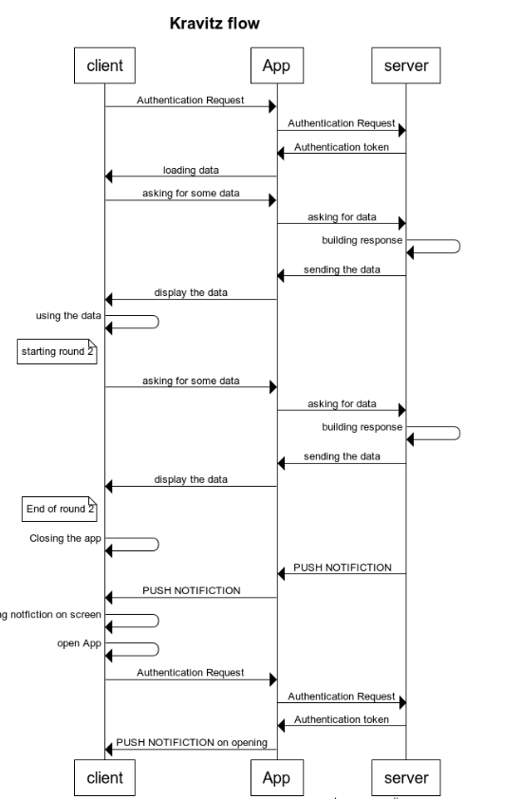

Unauthorize user flow

TBC

Mockup



Server Side
In this section you will provide more detailed description of the server-side functionality and structure

API

User:
1. login
Request
Response
2. get_birthdays
Request
Response
3. add_user
Request
Response
4. remove_user
Request
Response
5. load_all_users_from_file
Request
Response

Daily Breifing:
6. get_daily_briefing
Request
Response
7. get_daily_briefing_list
Request
Response
8.remove_daily_briefing
Request
Response
9.add_daily_briefing
Request
Response
10.update_daily_briefing
Request
Response

Important Message:
11. get_important_messages
Request
Response
12.update_important_messages
Request
Response
13.add_important_message
Request
Response
14.remove_important_message
Request
Response

HR Files:
15.remove_human_resources_file
Request
Response
16.add_human_resources_file
Request
Response
17.update_human_resources_file
Request
Response
18.get_human_resources_files
Request
Response\
19.load_human_resources_file
Request
Response

Important Info File:
20.remove_important_info_file
Request
Response
21.add_important_info_file
Request
Response
22.update_important_info_file
Request
Response
23.get_important_info_files
Request
Response\
24.load_important_info_file
Request
Response

Manager Guides:
25.remove_manager_guide
Request
Response
26.add_manager_guide
Request
Response
27.update_manager_guide
Request
Response
28.load_manager_guide
Request
Response\
29.get_all_manager_guides
Request
Response

Employee Guides:
30.remove_employee_guide
Request
Response
31.add_employee_guide
Request
Response
32.update_employee_guide
Request
Response
33.load_employee_guide
Request
Response
34.get_all_employee_guides
Request
Response

Bonus List:
35.get_bonus_list
Request
Response
36.add_bonus
Request
Response
37.remove_bonus
Request
Response

Conventions
Status Codes

Methods

1. login
Authenticate the user with the system and obtain the auth_token

Request
Method | URL
POST | api/login/

Type | Params | Values
HEAD  POST  POST | api_key  username  password | string  string  string

api_key
api_key must be sent with all client requests. The api_key helps the server to validate the request source.

Response
Status | Response
200 | {  "auth_key": <auth_key>  }  auth_key (string) - all further API calls must have this key in header
403 | {"error":"API key is missing."}
400 | {"error":"Please provide username."}
400 | {"error":"Please provide password."}
401 | {"error":"Invalid API key."}
401 | {"error":"Incorrect username or password."}
500 | {"error":"Something went wrong. Please try again later."}

